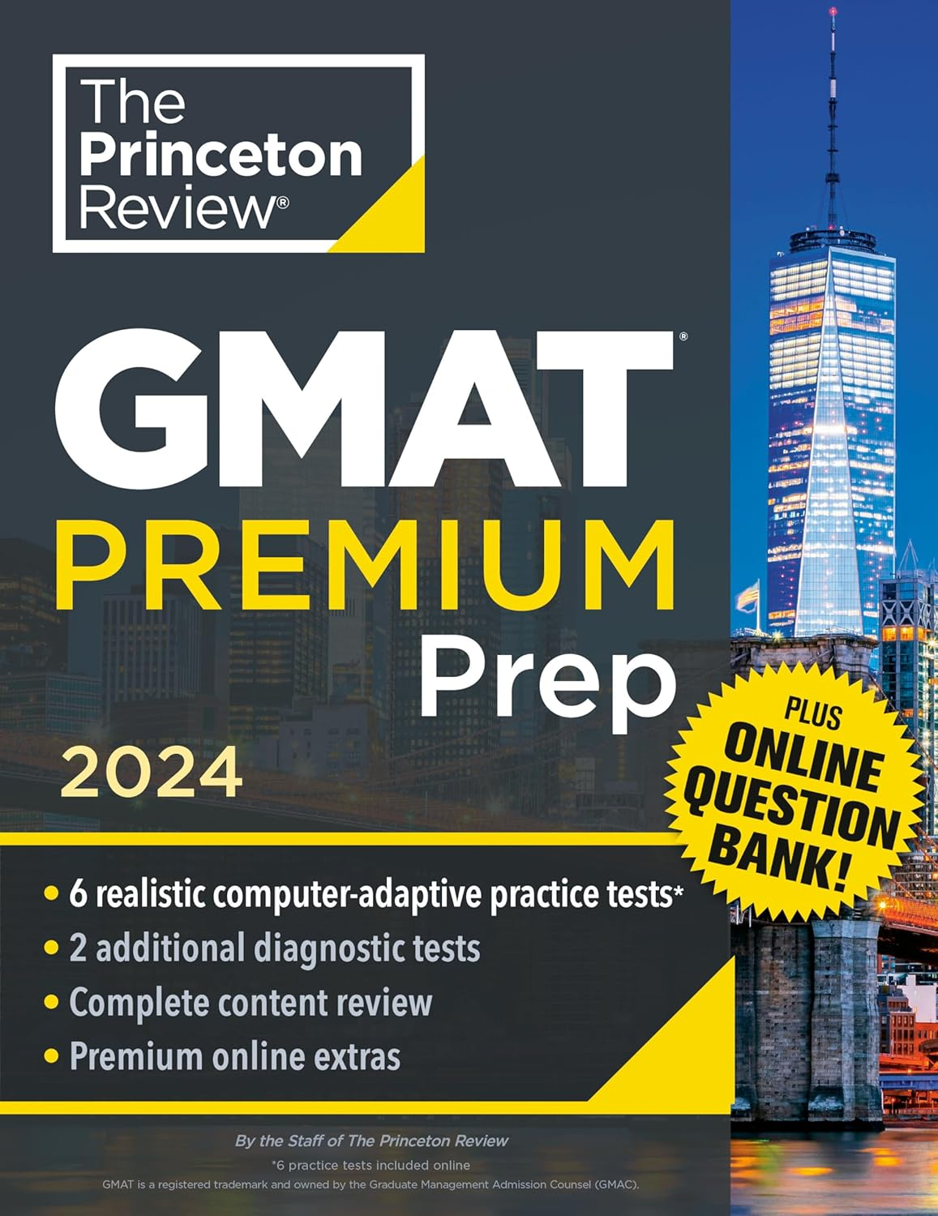 **₦**63,700

**Princeton Review GMAT Premium Prep, 2024: 6 Computer-Adaptive Practice Tests + Online Question Bank + Review & Techniques (2024) (Graduate School Test Preparation)**

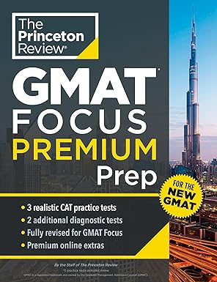 **₦**75,750

# Princeton Review GMAT Focus Premium Prep: 3 Full-Length CAT Practice Exams + 2 Diagnostic Tests + Complete Content Review (Graduate School Test Preparation)

# C:\Users\MEC\Desktop\GMAT textbook 3.jpg ₦79,000

# GMAT Official Guide 2024-2025: Book + Online Question Bank (GMAT Official Guides)

# C:\Users\MEC\Desktop\GMAT textbook 4.jpg ₦74,000

# GMAT Focus Edition Prep 2024 and 2025: 2 Practice Tests and GMAT Study Guide Book [Updated for the New Exam Outline]